**Global options for files**

**Introduction**

In previous lessons, you explored the importance of data flows, reference queries, and query parameters and examined the best practices when working with Microsoft Power Query. As a data analyst using Power BI, you may work in advanced scenarios requiring fine-grained management of how Power Query loads data. In this reading, you’ll explore global options for Power BI files. The global options refer to the settings and configurations that apply to all files and reports within the Power BI environment.

**Global options for Power BI files**

Power BI offers various **global options** that allow you to customize and optimize your experience when working with files. These options provide

* flexibility
* control over file settings
* ensure a seamless workflow
* enhance overall productivity.

 With these options, you can define default behaviors such as language settings, formatting and data load preferences to ensure consistency and to streamline the overall user experience across multiple files.

**Locate global options**

* To work with **global options** for files in Microsoft Power BI Desktop, you need to navigate to the **File** menu. Then, select **Options and Settings**, followed by **Options**.

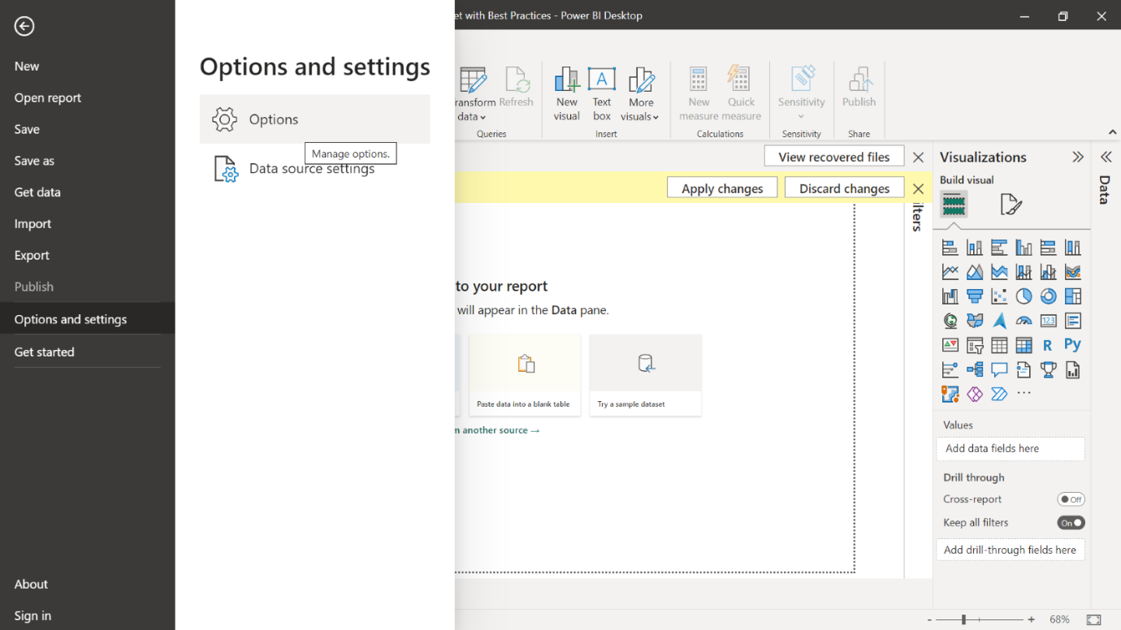

* In the **Options** window, there are 2 main options, **Global** and **Current File**. In this reading, you’ll focus on the **Global** settings. However, you can use the **Current File** menu to change the settings for any file you’re currently working on.

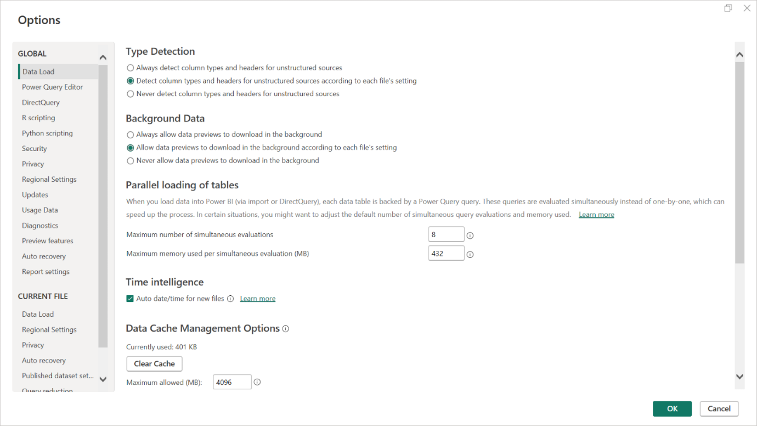

Now, let’s explore the key **global options** available in Power BI Desktop and their functionalities.

**File storage options**

Power BI offers two primary file storage options: OneDrive for Business and SharePoint Online. These cloud-based storage solutions provide secure and reliable storage for your Power BI files. By choosing the appropriate storage option, you can easily collaborate with team members, share files, and ensure data accessibility across your organization.

**Privacy levels**

Privacy levels in Power BI determine the level of data isolation between different data sources and establish secure boundaries for data interaction within your Power BI environment. They ensure that sensitive data is protected and prevent unauthorized access or data leakage. You can set privacy levels for each data source based on the sensitivity of the data. This ensures that only authorized users can access and combine data from different sources, maintaining data security and compliance.

The available privacy levels include the following:

* The **Private** privacy level in Power BI ensures that data is accessible only to the specific user who created or uploaded it, providing the highest level of data isolation and privacy.
* The **Organizational** privacy level in Power BI allows data to be shared within the organization, granting access to authorized users and maintaining data security within the organizational boundaries.
* The **Public** privacy level in Power BI enables data to be shared publicly, allowing anyone to access and view the data, making it suitable for public datasets or open data initiatives.

**Query folding**

**Query folding** is a performance optimization technique that pushes data transformation operations to the data source instead of performing them within Power BI. By enabling **query folding**, Power BI leverages the capabilities of the underlying data source, resulting in faster and more efficient data retrieval. As such, enabling **query folding** is recommended to optimize query performance, especially when working with large datasets or complex data sources. This approach is particularly beneficial when dealing with databases or systems that can efficiently process and execute the transformations, resulting in faster and more efficient query execution.

**Data load options**

Power BI offers different data load options including:

* **Load**: This data load option loads the entire dataset into the Power BI model.
* **Load to**: This data load option allows you to specify a destination for the loaded data, such as a table or a data model.

By choosing the appropriate data load option, you can optimize memory usage and improve overall performance.

**Power Query Editor options**

**Power Query Editor** provides advanced options for data transformation and shaping. Within the editor, you can customize various settings, such as enabling the formula bar, adjusting row limits, managing query dependencies, and enabling or disabling query previews. These options allow you to tailor the **Power Query Editor** environment to your specific requirements, enhancing your data preparation and transformation process.

**Conclusion**

For aspiring Power BI analysts, exploring and using the **global options** available in Power BI can greatly enhance file management and data processing capabilities. From choosing the appropriate file storage option to optimizing query performance and customizing **Power Query Editor** settings. The global options you learned about in this reading enable you to tailor Power BI to your specific needs.

**Note:** It's recommended to regularly review and adjust the **global options** as your needs change so that you can optimize your Power BI experience.

By effectively using these **global options**, you can streamline your workflow, improve data processing and report generation performance, and gain increased control over data-related tasks.